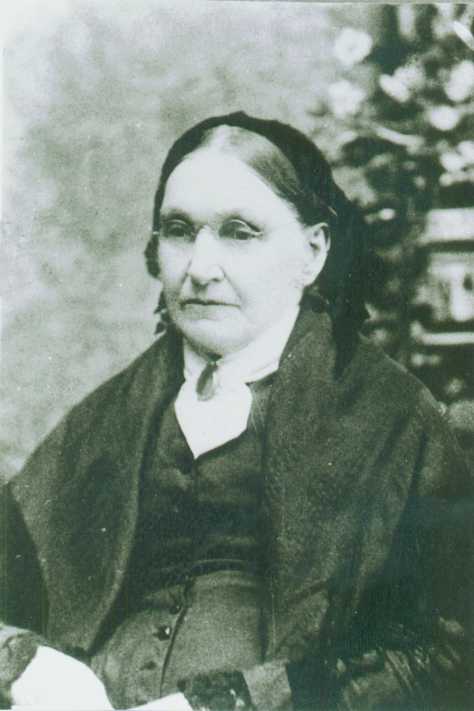
Lavina Wollerton Dilworth Harper
1818-1903
“Daughters of the Utah Pioneers,” p. 1252

Lavina was born in Chester, Pennsylvania in 1818. Lavina was the fifth daughter in a family of twelve girls and one boy.

Prior to his conversion, her husband, Charles, did not like the Mormons and when his wife became one he told her he would not walk down the street with a Mormon. So he walked down one side and she would walk down the other. They did this for one year. One day he walked away from home and said he would be back soon. Lavina started her washing and it was not very long before she heard him coming home, he had been baptized.

The Harpers were among the thousands who assisted in establishing Winter Quarters. Charles was a carriage maker and wheelwright and was included in the first pioneering migration, under Brigham Young, to the Salt Lake Valley.

Lavina was a good tailor and while he was gone she made enough money to buy a wagon. He returned in the Fall of 1847, and in the Spring of 1848, with their five year old son, they set out to join the Saints in the Salt Lake Valley. Lavina was pregnant with her fifth child. She drove the heavily loaded covered wagon and a pair of oxen, most of the distance. The baby was born before they reached Utah.

This pioneer family was able to overcome the effects of cricket plagues and other hardships. They became skilled in making butter, cheese. bread, candles, soap, lye, starch, and in drying the wild fruits.

Lavina was a noble and true pioneer. She was loved by her family and all who knew her.

